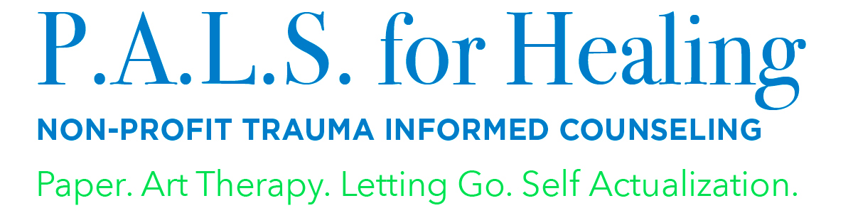
Misty Ramos-Saviano, ATR, LPCC-S, ACTP, EMDR
Executive Director, P.A.L.S. for Healing
misty@palsforhealing.org
330-518-8334

NEWS RELEASE
P.A.L.S. for Healing Receives Grant from Thatcher Family Fund,
part of The Cleveland Foundation

Grant will assist with funding a portion of our support group program for the underserved during 2019.

(Independence, Ohio May 2019) –
P.A.L.S. for Healing was the recipient of a $5,000 grant from the Thatcher Family Fund. This grant will provide art therapy supplies for support group sessions for clients to process trauma and loss, and then have tangible reminders of the skills they learned after the group is complete. It will also allow P.A.L.S. for Healing to market our groups and cover the cost of program space to run the groups. Additional funds will also be used toward administrative support costs. With this grant, we will be able to help additional children and youth work through their traumatic experience and who would not otherwise be able to afford services. Our goal is to also build up their family and support network by increasing their positive coping skills.

P.A.L.S. for Healing is thankful for this funding from the Thatcher Family Fund by being able to serve more families in our community.
About P.A.L.S. for Healing

P.A.L.S. for Healing is a nonprofit mental health organization formed in 2010 providing counseling and support services to children who experience trauma. Her focus on those most vulnerable is a long-standing personal mission. P.A.L.S. for Healing has four locations within Cuyahoga County and provides offsite group and individual services within Cuyahoga, Lake and Summit counties. We provide professional workshops and training for individuals and organizations. We provide art therapy support group services for youth aging out of the foster-care system, families affected by parental incarceration, families affected by substance use and monthly art therapy workshops for military families. For additional information about our programs, please visit palsforhealing.org.

BEST PRACTICES:

• Focus the message of the press release on how the funds will serve the community and impact the future of the community
o Use numbers to drive home the impact (e.g. # of people assisted, amount donated, etc.)
• Send your press release to local papers and Philanthropy Ohio
• Images garner more attention! Add a few photos, like the photo with the big check and images of your organization at work, to the press release and social media posts.
• For any questions or a review of your press release and distribution plan please reach out to the CareSource Media Relations team:
o Fran Robinson, Manager, Media Relations
▪ Office: 937-531-2374
▪ Cell: 937-581-7914
▪ Francine.Robinson@CareSource.com
o Stephanie Irwin, Sr. Media Relations Specialist
▪ Office: 937-487-2017
▪ Cell: 937-751-3967
▪ Stephanie.Irwin@CareSource.com
o Veronica Nunamaker, External Communications Specialist
▪ Office: 937-487-4051
▪ Cell: 937- 903-7346
▪ Veronica.Nunamaker@CareSource.com

