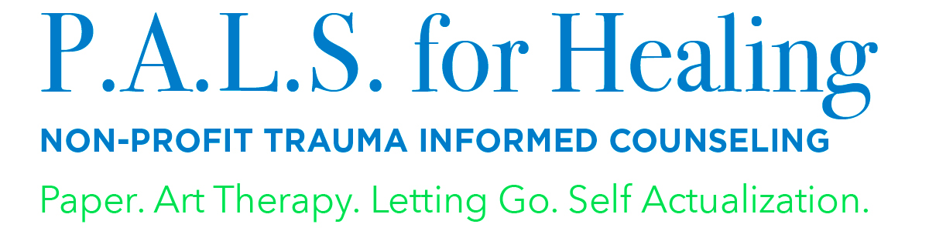
Misty Ramos-Saviano, ATR, LPCC-S, ACTP, EMDR
Executive Director, P.A.L.S. for Healing
misty@palsforhealing.org
330-518-8334

NEWS RELEASE
P.A.L.S. for Healing Receives Grant from Ohio Arts Council

Grant will assist with strengthening support staff in order for P.A.L.S. for Healing to grow in 2019.

(Independence, Ohio July 2019) –
P.A.L.S. for Healing was the recipient of a $5,000 grant from Ohio Arts Council. This will allow the organization to add a graphic artist and event management consultant along with a consultant who is experienced in strategy and fund development. They will help the board and staff continue reaching the goals of our strategic plan and maintain the positive momentum by meeting key performance indicators. Their support will also increase fund development for P.A.L.S. for Healing’s fundraisers and events. “Our goal is that by increasing the hours of these positions, we will be able to increase the community’s awareness of P.A.L.S. and how effective art and trauma-informed therapies can be for individuals working through trauma or loss,” said Misty Ramos-Saviano, Executive Director.

P.A.L.S. for Healing is grateful for this support that will allow us to serve the unprecedented growth we’ve seen each year due to the increase in referrals from other mental health organizations and community partners.
About P.A.L.S. for Healing

P.A.L.S. for Healing is a nonprofit mental health organization formed in 2010 providing counseling and support services to children who experience trauma. Her focus on those most vulnerable is a long-standing personal mission. P.A.L.S. for Healing has four locations within Cuyahoga County and provides offsite group and individual services within Cuyahoga, Lake and Summit counties. We provide professional workshops and training for individuals and organizations. We provide art therapy support group services for youth aging out of the foster-care system, families affected by parental incarceration, families affected by substance use and monthly art therapy workshops for military families. For additional information about our programs, please visit palsforhealing.org.

BEST PRACTICES:

• Focus the message of the press release on how the funds will serve the community and impact the future of the community
o Use numbers to drive home the impact (e.g. # of people assisted, amount donated, etc.)
• Send your press release to local papers and Philanthropy Ohio
• Images garner more attention! Add a few photos, like the photo with the big check and images of your organization at work, to the press release and social media posts.
• For any questions or a review of your press release and distribution plan please reach out to the CareSource Media Relations team:
o Fran Robinson, Manager, Media Relations
▪ Office: 937-531-2374
▪ Cell: 937-581-7914
▪ Francine.Robinson@CareSource.com
o Stephanie Irwin, Sr. Media Relations Specialist
▪ Office: 937-487-2017
▪ Cell: 937-751-3967
▪ Stephanie.Irwin@CareSource.com
o Veronica Nunamaker, External Communications Specialist
▪ Office: 937-487-4051
▪ Cell: 937- 903-7346
▪ Veronica.Nunamaker@CareSource.com

